Bank-Linked Wallet
# Source: AI Source: Provided by: [Data Path: Persons Table -> ID Column: 1, Name_En Column: Motasem Essam] -> From: [ChatGPT] on [1/21/2026]
A Bank-linked wallet is a type of digital wallet that is directly connected to a user's bank account. It allows users to perform transactions (like payments, transfers, and bill payments) by pulling funds from or pushing funds to a linked bank account.

✅ Key Features of Bank-Linked Wallets:
# Source: AI Source: Provided by: [Data Path: Persons Table -> ID Column: 1, Name_En Column: Motasem Essam] -> From: [ChatGPT] on [1/21/2026]
- Direct Bank Integration
  - Funds are debited or credited directly from the user's bank account.
  - No need to load money into a separate wallet balance.
- Authentication & Security
  - Often uses multi-factor authentication (e.g., OTP, biometrics, PIN).
  - Transactions are subject to banking-grade KYC/AML rules.
- Real-Time Transactions
  - Uses instant payment rails (e.g., UPI in India, Faster Payments in the UK).
  - Payments are processed in real time or near real time.
- No Prepaid Limitations
  - Not limited by prepaid wallet balance or top-up restrictions.
  - The spending limit is often the same as the linked bank account.
- Use Cases
  - Online purchases
  - Peer-to-peer (P2P) transfers
  - Utility and bill payments
  - Merchant payments (QR code, NFC, etc.)

🔄 Examples of Bank-Linked Wallets:
# Source: AI Source: Provided by: [Data Path: Persons Table -> ID Column: 1, Name_En Column: Motasem Essam] -> From: [ChatGPT] on [1/21/2026]
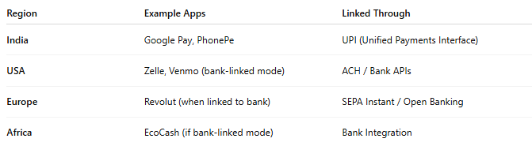

Region | Example Apps | Linked Through
India | Google Pay, PhonePe | UPI (Unified Payments Interface)
USA | Zelle, Venmo (bank-linked mode) | ACH / Bank APIs
Europe | Revolut (when linked to bank) | SEPA Instant / Open Banking
Africa | EcoCash (if bank-linked mode) | Bank Integration

🆚 Comparison with Other Wallet Types
# Source: AI Source: Provided by: [Data Path: Persons Table -> ID Column: 1, Name_En Column: Motasem Essam] -> From: [ChatGPT] on [1/21/2026]
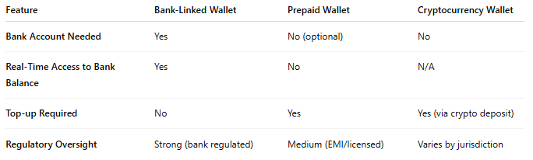

Feature | Bank-Linked Wallet | Prepaid Wallet | Cryptocurrency Wallet
Bank Account Needed | Yes | No (optional) | No
Real-Time Access to Bank Balance | Yes | No | N/A
Top-up Required | No | Yes | Yes (via crypto deposit)
Regulatory Oversight | Strong (bank regulated) | Medium (EMI/licensed) | Varies by jurisdiction

✅ Benefits:
# Source: AI Source: Provided by: [Data Path: Persons Table -> ID Column: 1, Name_En Column: Motasem Essam] -> From: [ChatGPT] on [1/21/2026]
- Seamless transactions from bank accounts
- No need to maintain wallet balance
- Faster onboarding via bank authentication
- Trusted due to regulatory compliance

⚠️ Challenges:
# Source: AI Source: Provided by: [Data Path: Persons Table -> ID Column: 1, Name_En Column: Motasem Essam] -> From: [ChatGPT] on [1/21/2026]
- Limited availability in countries with weak bank API infrastructure
- Dependence on bank uptime and APIs
- Requires strong KYC

